Green computing

a Dr. Anu priya jain ,b Suman Kumar ,c Sunil Kumar, d Sourabh Anand

a Faculty of Computer Application  
Manav Rachna International Institute of Research and Studies*)*

Faridabad, 121002, India  
[anupriya.fca@mriu.edu.in](mailto:anupriya.fca@mriu.edu.in)

b Student of Computer Application  
Manav Rachna International Institute of Research and Studies*)*

Faridabad, India  
[sumankumarmca022@gmail.com](mailto:sumankumarmca022@gmail.com)

c Student of Computer Application  
Manav Rachna International Institute of Research and Studies*)*

Faridabad, India  
starbhailive@gmail.com

d Student of Computer Application  
Manav Rachna International Institute of Research and Studies*)*

Faridabad, India  
sourabhanand3417@gmail.com

Abstract:

Green computing is a term used to describe the practice of reducing the energy consumption and environmental impact of computer and IT equipment during their entire lifecycle. Green computing strategies include improving the energy efficiency of existing computer systems and equipment, controlling emissions and waste from the manufacturing process, and extending the useful life of computer systems and components. This paper provides an overview of green computing, including the challenges and opportunities associated with this concept, as well as the various strategies and technologies used to reduce the environmental impact of computing. It also discusses the role of policymakers and businesses in promoting green computing initiatives, as well as the need for continued research and development in this field.

Acknowledgment:

We would like to express our gratitude to our mentor Dr. Anu Priya Jain, for her constant assistance and feedback throughout this research paper, her lectures on research techniques assisted us in finishing this research in a responsible way.

1. **Introduction**

Green computing is a term used to describe the practice of reducing the energy consumption and environmental impact of computers and IT equipment during their entire lifecycle. It is an important component of the larger movement toward sustainability, which seeks to reduce the impact of human activities on the environment. Green computing strategies include improving the energy efficiency of existing computer systems and equipment, controlling emissions and waste from the manufacturing process, and extending the useful life of computer systems and components. This paper provides an overview of green computing, including the challenges and opportunities associated with this concept, as well as the various strategies and technologies used to reduce the environmental impact of computing. It also discusses the role of policymakers and businesses in promoting green computing initiatives, as well as the need for continued research and development in this field.

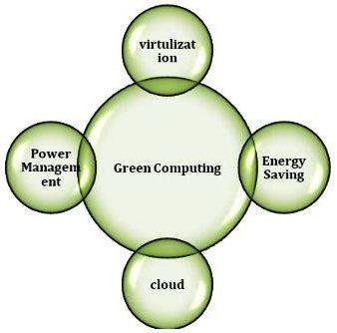

# Fig1. Fundamental Techniques of Green Computing

Green computing is the practice of using computers, software, and other technology in an environmentally responsible way. It involves the use of energy-efficient computer hardware and software, recycling and disposal of obsolete electronic equipment, and the use of renewable energy sources to power computer systems. It also focuses on reducing the use of hazardous materials and promoting the use of recycled materials in the production of computer equipment. Green computing is an important part of creating a sustainable world and reducing the environmental impact of technology. Green computing refers to the environmentally sustainable use of computers and related resources, which includes the implementation of energy-efficient systems, the responsible disposal of electronic waste, and the design of products with a reduced environmental impact. The goal of green computing is to minimize the negative impact of technology on the environment by reducing energy consumption, using renewable energy sources, and promoting recycling and the use of environmentally-friendly materials.

1. **Energy Efficiency**

Energy efficiency is one of the key strategies in green computing. To reduce the energy requirements of computers and IT systems, CPU speed, system memory, and other components must be monitored and optimized to ensure they are running at the most efficient level. This can be achieved through the use of energy-efficient hardware, software, and power management technologies.

Power management technologies can be used to reduce the energy consumption of computer systems by automatically switching them off when not in use or when the user is away from their desk. This can be achieved through the use of energy-efficient monitors, power supplies, and other components. Additionally, the software can be used to optimize system settings for energy efficiency.

Green computing is the practice of using computing resources efficiently and in an environmentally friendly manner. It includes reducing energy consumption, using recycled materials, and reducing paper waste. Energy efficiency is one of the most important aspects of green computing.

There are several ways to improve the energy efficiency of green computing. One way is to purchase energy-efficient hardware and software. This includes selecting hardware and software that is designed to use the least amount of energy. Additionally, virtualization technology can be used to reduce the number of physical servers needed, thus reducing the overall energy consumption.

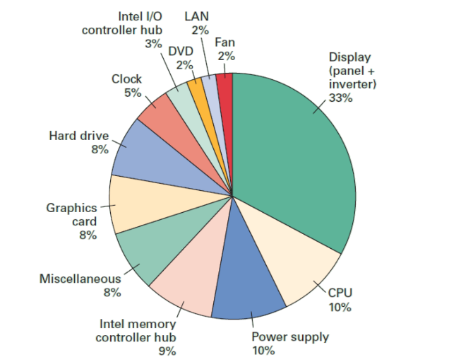

**Fig2**. Energy Efficiency

Another way to increase the energy efficiency of green computing is to use efficient energy management systems. These systems monitor and regulate the energy usage of the hardware used in the system. They are designed to reduce the energy consumption of hardware by turning off power to components when they are not in use.

Finally, advanced cooling systems can be implemented to reduce the energy consumption of the system. Advanced cooling systems use fans and other cooling methods to reduce the temperature of the system, thus reducing the amount of energy required to cool the system.

By following these energy efficiency tips, green computing can be an effective way to reduce energy consumption and help the environment.

1. **Framework of Green Computing.**

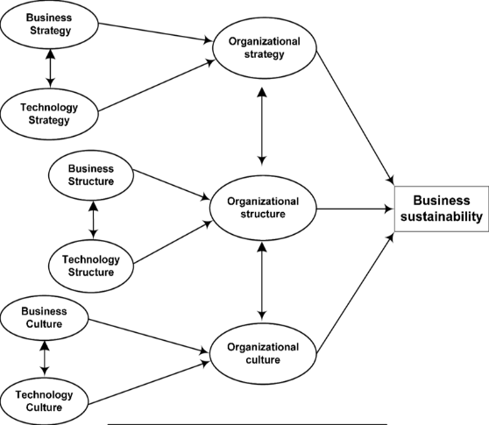

# Fig3. Framework of Green Computing

**3.1 Energy-Efficient Technologies:** Implementing energy-efficient technologies such as energy-efficient processors, efficient memory, and hard drives can reduce energy consumption and the costs associated with it.

**3. 2 Waste Reduction:** Implementing recycling and reuse practices can help reduce waste and cut down on the costs associated with disposing of unused equipment.

**3. 3 Green Purchasing:** When making purchasing decisions, organizations should look for products with the lowest environmental impact and the highest energy efficiency rating.

**3.4. Cooling Systems:** Cooling systems use a great deal of energy, so utilizing green cooling technologies such as evaporative cooling, chilled water systems, and other efficient systems can help reduce energy consumption and costs.

**3.5. Server Consolidation:** Consolidating multiple servers onto fewer servers can reduce energy consumption and the costs associated with it.

**3.6. Software Optimization:** Optimizing software can help reduce energy consumption by reducing the number of processor cycles needed to run the software.

**3. 7. Network Optimization:** Optimizing a network can help reduce energy consumption by reducing the amount of data that needs to be transmitted over the network.

**3.8. Virtualization:** Virtualization can help reduce energy consumption by allowing multiple applications to run on the same server, thus reducing the amount of energy required to run them.

**3.9. Education:** Educating employees and customers about green computing practices can help reduce energy consumption and costs in the long run.

**3.10. Monitoring:** Monitoring energy consumption can help organizations identify areas where energy is being wasted and can help them develop strategies to reduce it.

1. **Manufacturing Process**

The manufacturing process of computer systems and components can have a significant environmental impact, due to the use of toxic materials and the emission of greenhouse gases. To reduce the environmental impact of the manufacturing process, green computing initiatives focus on controlling emissions and waste from the production of IT equipment. This can be achieved through the use of cleaner production processes, such as the use of recycled materials, the adoption of energy-efficient manufacturing systems, and the implementation of pollution prevention strategies.

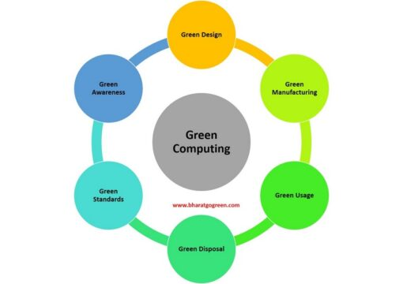

# Fig4. Manufacturing process of Green Computing

Green computing is the practice of creating and using computers and other digital devices in an environmentally responsible manner. This is done by reducing energy consumption, reducing the impact of e-waste, and utilizing renewable energy sources.

**4. 1. Design:** The first step in the green manufacturing process is to design products that are energy efficient and have a minimal environmental impact. This includes using materials that are recycled or recyclable, as well as components that have a long life-span. It is also important to minimize the use of hazardous chemicals in the manufacturing process.

**4. 2. Manufacturing:** The second step is to manufacture the components and products in an energy-efficient manner. This includes using energy-efficient production equipment, utilizing renewable energy sources, and minimizing waste. It is also important to use processes that are environmentally friendly, such as using water-based inks and avoiding the use of hazardous chemicals.

**4.3. Assembly:** The third step is to assemble the components and products into their final form. This includes using energy-efficient assembly processes, as well as using components that can be easily recycled or reused.

**4.4. Testing**: The fourth step is to test the products to ensure that they meet standards for energy efficiency and environmental impact. This includes testing the products for energy efficiency, emissions, and other environmental factors.

**4.5. Disposal:** The fifth step is to dispose of any e-waste in an environmentally responsible manner. This includes recycling or donating any components that are no longer usable. It is also important to ensure that any hazardous materials are disposed of properly.

1. **Green Design**

Green design is a concept that seeks to reduce the environmental impact of computer systems and components by focusing on the design and development of more energy-efficient and sustainable products. This can be achieved through the use of energy-efficient components, the use of recycled materials, and the development of products with longer lifespans. Additionally, green design initiatives focus on reducing the amount of waste generated during the manufacturing process and encouraging the reuse and recycling of IT equipment.

Green Design is a term used to describe the use of computer technology in a way that reduces its environmental impact. This includes the use of energy-efficient hardware and software, as well as practices such as recycling, reusing and repurposing components. It also includes using technologies such as virtualization, cloud computing and efficient data centres to reduce the power and resources needed to run applications and services. Green computing can help organizations save money and reduce their environmental footprint.

1. **Role of Policymakers and Businesses**

Policymakers and businesses have an important role to play in promoting green computing initiatives. Governments can play an important role by introducing policies and regulations that encourage the use of energy-efficient hardware and software, as well as the development of more sustainable IT products. Additionally, businesses can promote green computing through the adoption of green computing strategies, such as the use of energy-efficient hardware, software, and power management technologies.

Policymakers and businesses have a major role to play in creating an inclusive economy. Policymakers have the power to shape economic policies, labor laws, tax codes, and regulations to ensure that all stakeholders, especially those with the most potential to benefit, are included. Policymakers can create incentives for businesses to invest in low-income and marginalized communities, promote financial inclusion, and provide job opportunities. They can also establish laws and regulations that protect workers’ rights, provide access to education and vocational training, and create a fair and equitable playing field for all. Businesses also have a role to play in creating an inclusive economy. Companies can invest in communities that are often overlooked and encourage their employees to volunteer or mentor in those areas. They can also reduce wage gaps and ensure equal opportunities for people from all backgrounds. Additionally, businesses can provide access to financial services that support the financial health of their employees, customers, and communities. By engaging in activities that promote an inclusive economy, businesses can contribute to a healthier, more prosperous society.

1. **Need for green computing**

**1. Reduce Energy Consumption:** Green computing reduces the energy consumed by computer systems, which in turn reduces carbon emissions and decreases the amount of energy used to power and cool computer systems.

**2. Reduced Waste:** Green computing reduces the amount of electronic waste generated by computer systems, helping to minimize the impact of electronic waste on the environment.

**3. Increased Efficiency:** Green computing helps to increase the efficiency of computer systems, reducing their energy consumption and increasing their performance.

**4. Improved Productivity:** Green computing offers the potential to improve productivity, as computer systems that are more energy efficient and produce less waste are more likely to be used more efficiently and productively.

**5. Cost Savings:** Reducing the energy consumption of computer systems can result in significant cost savings, as less energy is required to power and cool the systems.

**6. Environmental Sustainability:** Green computing helps to create a more sustainable environment, as computer systems that consume less energy and produce less waste are less likely to have a negative impact on the environment.

1. **Conclusion**

Green computing is an important concept that seeks to reduce the energy consumption and environmental impact of computer and IT systems. It is an important component of the larger sustainability movement and is becoming increasingly important as the world faces the challenges of climate change and resource depletion. Green computing strategies include improving the energy efficiency of existing computer systems and equipment, controlling emissions and waste from the manufacturing process, and extending the useful life of computer systems and components. Additionally, policymakers and businesses have an important role to play in promoting green computing initiatives. Going forward, continued research and development will be needed to reduce the environmental impact of computing.

References

[1] http://www.wipro.in/Products/greenpc/in dex.htm#1[Last visited on 25th December, 2011].

[2] http://www.redbooks.ibm.com/abstracts/redp4413.html [Last visited on December, 2011].

[3] http://www.csi-india.org [Last visited on 24th October, 2011].

[4] Green Computing and Green IT Best Practices on Regulations and Industry Initiatives, Virtualization, Power Management, Materials Recycling and Telecommuting by Author Jason Harris , 2008 .

[5] http://green.wikia.com/wiki/Green_Computing. [Last visited on 2th January, 2012].

[6] <http://thefutureofthings.com/articles/1003/green-computing.html>

[7] Wu-chun Feng (Editor). Green Computing: Large-Scale Energy Efficiency. CRC Press. January 2011.

[8] John Lamb. The Greening of IT: How Companies Can Make a Difference for the Environment. IBM Press; May, 2009, ISBN-13: 9780137150830. [9] John Lamb. The Greening of IT: How Companies Can Make a Difference for the Environment. IBM Press; May, 2009, ISBN-13: 9780137150830.